Sam Barham  (Head) | Staff | I studied at Leeds’ Metropolitan University where I achieved a B.Ed (hons) in Physical Education. I taught PE for eleven years and for ten of those I was also Head of PE. When I moved to Devon I made a conscious decision to learn more about SEN and to gain experience in this field so stepped away from PE.  I helped to set up and then teach in a KS3 Pupil Referral Unit in  Barnstaple and then, got a job teaching part-time at Lampard in 2005 after the birth of my daughter. I worked at Lampard in various roles including developing and managing the Outreach service the school provided, transition, CPD, developing Tuesday Training alongside Claire Cowen-Brown, PE co-coordinator and began the Forest School provision within this subject, as well as being a tutor and delivering Entry Level Sport and Leisure Option. I finished my career as the Acting Deputy Headteacher which I left in July 2016.  Last year I worked for Babcock LDP service within the  Communications and Interactions Team for a year before coming to work as the Headteacher at Lampard.
Vacancy | Staff

Andrew Redpath | Foundation | May 2016 – Gov start date  I joined the governing body in April 2016 after a varied career in education. I taught in secondary and special schools, and was a headteacher in a special school before becoming a school inspector (HMI).  I retired in 2015 but undertakes occasional school improvement work.
Vacancy | Foundation
Peter How  (Vice-Chair)  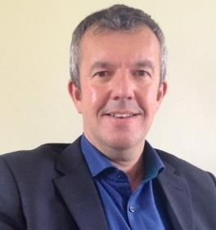 | LEA | Oct 2011 governor start date  Hi, My name is Peter How and I've been a School Governor since October 2011. I enjoy the role of being a Governor, it's very different to my day job in the Construction Industry. I hope I bring some experience that I've gained of running a business in the Private Sector to the School Governing Body.  I particularly enjoy my visits to school, it's always a pleasure to meet the staff and pupils. I'm always impressed with the pupils’ politeness, confidence, enthusiasm and keenness for learning! I am a keen sportsman with particular interest in golf, cricket and rugby.  I look forward to continuing with the role of being a School Governor at Lampard and seeing the School improve on its already high standards.
Christine Bevan  (Vice-Chair) | Co-opted | April 2019 – governor start date  I was co-opted onto the Governing Body in April 2019 and elected as Vice Chair at the beginning of the autumn term. I have worked as a Chartered human resource practitioner for organisations in the public and private sector and was a Company Director for a human resource consultancy for 11 years. I am also a qualified teacher and taught management and leadership before moving on to manage higher education provision within the further education sector. Subsequently I worked for the Quality Assurance Agency for Higher Education where I led reviews and reported on academic standards, in addition to the quality of teaching and learning within universities, colleges and private providers. I have been impressed by the positive learning environment within the School; the enthusiasm and attitude of pupils and the commitment of staff in enabling pupils to realise their potential. I hope that I can use my skills to build upon the positive work and performance of the School over recent years; in what has been and continues to be a very challenging external environment.
Claire Cowen-Brown | Co-opted | 18/01/10 Lampard start date  I have worked at Lampard since 2010 and am the Head of Care and Safeguarding. I moved to Devon in 2005 from Sheffield and have worked in primary and secondary schools in pastoral roles as well as in educational projects and youth work. I studied at Sheffield Hallam University and Marjon in Social Studies and Psychology. In my spare time, I’m a total bookworm and also enjoy art, history, sport and music.
Kevin Harris  (Chair)  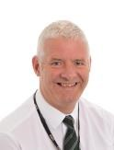 | Co-opted | June 2010 gov start  Hello, I am in my second four year term as a Governor having joined Lampard in June 2010. As guest presenter at an Awards event I was so incredibly impressed with the school, the students and staff. Retiring after 30 years police service in 2012, I now work part-time as Town Clerk for Lynton & Lynmouth Town Council, some teaching at Petroc and Presiding Officer at election time.  I became Chair of Governors in 2015. I try to use my experience of organisational management, performance and budget outcomes to continuously improve and support our school to provide the best inclusive education and fulfilling life expectations for students and their families.
Bill Robinson | Co-opted
Fiona Corbin  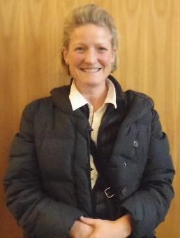 | Parent | Oct 2010  I have been a parent governor for 6 years and I am particularly interested in helping the school develop their therapeutic provision and Post 16 education.  I am a busy mother of 2, who enjoys horse-riding.
Andrew Palmer | Parent | My daughter attends Lampard and I am very committed to ensuring that students with SEND get the same opportunities and access to services that students in mainstream schools do. As such when the opportunity to join the Governing body came up. I put my name forward and was privileged enough to be elected.  I am a full time police officer based in North Devon. Prior to working in the Police I worked in IT for eight years. My last role was as IT services manager at Eaton Aerospace in South Molton. Before working in IT I spent 12 years in the Army serving all over the world.
Elaine Penfold | Parent | Oct 2017  My son attends Lampard Community School and has been a student for 4 years.  I am interested in S.E.N, inclusion for all and continuing the schools vision to enable all students to achieve their full potential.  My 'me' time is spent cycling and swimming.

