Jennie Harvey  (Head) | Staff | I was delighted to be appointed as interim Head Teacher in September  2022. I joined the school in 2017, initially as a tutor and then as Assistant Head Teacher for Teaching and Learning, and latterly as Deputy Head Teacher.  My teaching career has taken me far and wide; having career changed and trained in North Devon on the SCITT programme, I then worked in several Primary schools in the area and also taught for a year in Tanzania and for five years on a RAF base in Cyprus.  I have always held the teaching of students with SEND at the heart of my career. I also have many years of leadership and management experience outside of the education sector (having previously worked in the publishing industry) and I will bring all these skills together to ensure Lampard Community School remains the centre of excellence it has become.
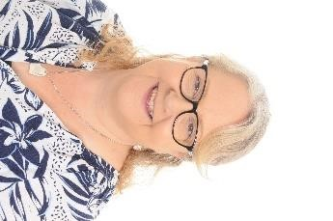  Lorraine Ovey | Staff | I joined Lampard as a Middle School class teacher in September 2019, having previously worked in mainstream primary schools in Northamptonshire and North Devon. I really care about education and providing high quality learning experiences for our students. I recently became a Middle Leader and maths subject lead. I really enjoy being a Governor and contributing to the bigger picture of school life.

Andrew Redpath | Associate | I joined the governing body in April 2016 after a varied career in education. I taught in secondary and special schools, and was a headteacher in a special school before becoming a school inspector (HMI).  I retired in 2015 but undertakes occasional school improvement work.
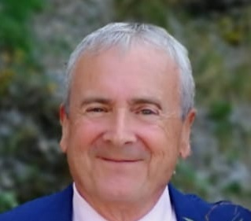 | Associate  Martin Bevan | I have worked for Devon County Council for 7 years dealing mainly with schools in North Devon as a Health and Safety Advisor. For the past two years I was seconded onto the Devon Public Health team where I led on the Covid 19 response in Devon schools. It was always my wish when I retired to use my skills to help schools provide children with an excellent place to learn and thrive in.  I am a Chartered Member of the Institute of Occupational Safety and Health. I have a BSc and a MSc in Health and Safety Management as well as being a qualified teacher in post compulsory education. I have taught in the further and higher education sector.  Throughout my working life I have been a volunteer in various capacities and have been a Trustee for both The Council for Administration and for Bristol Family Mediation Service as well as a staff governor in the Further Education Sector.  My skills are in the areas of premises management; health and safety compliance and teaching and training. I have an in-depth knowledge of the education sector. I have been a Trustee and Governor in organisations that have gone through mergers and restructuring and played a major role in the due diligence process of these mergers.
Amanda Burrows  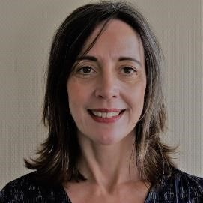 | Foundation | Having had a long career in education, I am extremely proud to be part of the Governing Body at The Lampard School. I have been in many different roles since 1999 when I first qualified: a teacher, SENCo, deputy headteacher, headteacher and in two local authorities as an Inclusion Adviser, SEND Adviser and School Effectiveness Adviser. I really value the role that governors bring and have been part of four governing bodies in the past. I am currently leading as Head of Therapeutic Education across four alternative provision sites for a thriving Devon charity.  I want to get to know The Lampard School and its community and learn how best to support it going forward. I hope that my skillset will complement what is already a successful board and make a strong contribution to the developments in school
Vacancy | Foundation

Vacancy | LEA
Christine Bevan  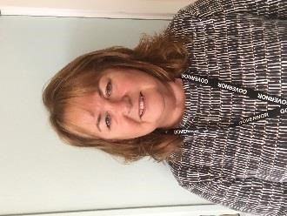  Chair) | Co-opted | I was co-opted onto the Governing Body in April 2019 and elected as  Vice Chair at the beginning of the autumn term. I have worked as a Chartered human resource practitioner for organisations in the public and private sector and was a Company Director for a human resource consultancy for 11 years. I am also a qualified teacher and taught management and leadership before moving on to manage higher education provision within the further education sector. Subsequently I worked for the Quality Assurance Agency for Higher Education where I led reviews and reported on academic standards, in addition to the quality of teaching and learning within universities, colleges and private providers. I have been impressed by the positive learning environment within the School; the enthusiasm and attitude of pupils and the commitment of staff in enabling pupils to realise their potential. I hope that I can use my skills to build upon the positive work and performance of the School over recent years; in what has been and continues to be a very challenging external environment.

Ben Mitchell | Co-opted | I was co-opted onto the Governing Board in January 2022. I have more than 20 years’ experience working in Careers Education and Guidance. I am currently employed by Devon County Council, as part of the Heart of the South West ‘Careers Hub’, working in partnership  with Careers Leads in SEND Schools and Alternative Provision Academies throughout Devon.  I would very much like to use my experience and skills to support the governance at Lampard Community School.
Craig Banyard | Co-opted | I am passionate about shaping the next generation and believe that becoming a school governor at Lampard Community School is the perfect opportunity for me to make a positive impact on the education system. With extensive experience in both education and technology, I am confident that I can use my skills and knowledge to contribute meaningfully to the school's governing body.  As someone who has worked in education and technology for many years, I have a deep understanding of the challenges facing schools and educators today. I believe that by becoming a school governor, I can use my experience to help the school overcome these challenges and provide a better learning environment for the students.
Maxine Sheppard | Co-opted | I have been a TA at Lampard since November 2021, becoming a STA in April and I have never been happier. Lampard is my happy place. I have seen the difference and positive impact our school has on children and want to help in any way I can.  I am a member of the PTA and will take up the role as treasure in September.  Before coming to Lampard, I was a Kitchen Manager in another local primary school. I feel I can bring a wide range of knowledge, including cooking, health and hygiene and budgeting as we used to order all our own food and organise our own menus.
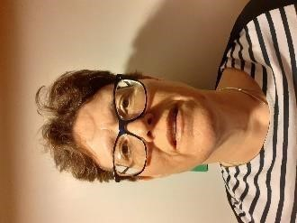  Hayley Hardy | Parent | I am mum to 2 Autistic /ADHD boys, my youngest in the Middle School going to Upper school next year.  I co-ordinate a parent support group, have been Chair of a PTFA , and lead a Scout group where 70% of the attendees have additional needs.  I strongly feel I want to give my thanks to Lampard to support them through this role. They are a much needed and appreciated establishment for families in need like us.
Vacancy | Parent
Vacancy | Parent

