Mrs S Barham
Headteacher
Lampard Community School
St John’s Lane
Barnstaple
Devon, EX32 9DD
Telephone: 01271 345416 e-mail: admin@lampard.devon.sch.uk www.lampard.devon.sch.uk

22nd March 2022
Dear Parents/Carers
Remote Learning Wednesday 23rd to Friday 25th March (inclusive)
Yesterday I wrote to advise you of the rising Covid cases and unfortunately due to further confirmed cases today, particularly amongst our leadership and staff team we have needed to make the difficult decision to close the school tomorrow to all students and to move into remote learning for the remainder of the week. This is a situation we had hoped we could have avoided but one we had prepared for in our contingency planning and is the safest for our community at this moment in time.
Our rising cases are being monitored by the UK Security and Health Agency as well as the Local Authority and we are guided by their advice. The decision to move to remote learning has not been taken lightly and safety remains the highest priority. We appreciate having the students at home during term time is not easy for families as many of you have work commitments – we also understand the disruption this will cause, as well as the change of routine for our young people.
A member of staff from your child’s tutor team will have tried to call you today to give you as much notice about the decision to move to remote learning. Please be aware our rising cases are reflected across the county. Tutor teams will have worked with students today to help them understand what the changes will be for the next three days. Your child will come home with their learning pack as well as details of how they can access online learning. If your child is off today, information will be emailed by the tutor team.
During the next three days, should you need to contact the school please email admin@lampard.devon.sch.uk and someone from the school team will respond to this as soon as they are able.
Devon’s Transport Department are being made aware of this situation so you will not need to make direct contact with your Driver or Escort.
If your child develops symptoms of COVID-19 or tests positive for COVID-19 they should get a PCR test (https://www.gov.uk/get-coronavirus-test or call 119) and remain at home at least until the result is known and they are fever free (without medication) for at least 24 hours.
- If negative, the child can return to school once well enough to do so
- If positive, the child should isolate as a positive case (see below)

People who test positive for COVID-19 should self-isolate at home until they are well enough to return, no longer have a temperature and either:
- 10 full days have passed, or
- They have produced two negative LFD tests on consecutive days, with the first taken no earlier than day 5. If your child does not have symptoms, count the day they took the test as day 0.

You can seek advice on COVID-19 symptoms from the nhs.uk website. If you are concerned about your child’s symptoms, or they are worsening you can seek advice from NHS 111 at https://111.nhs.uk/ or by phoning 111.
Further information is available at https://www.nhs.uk/conditions/coronavirus-covid-19/

We look forward to seeing your child back at school next Monday 28th March. If this date changes we will contact you with as much notice as possible.
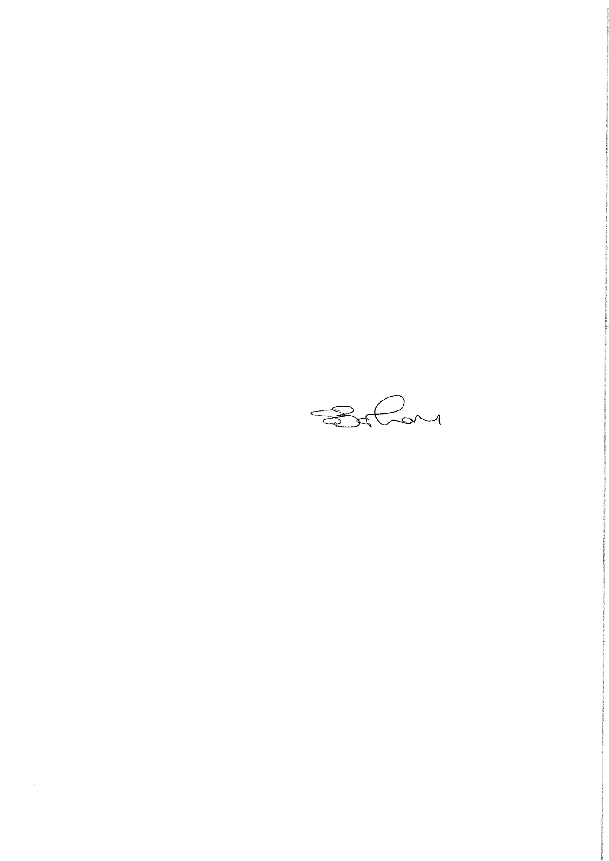
Yours sincerely
Sam Barham- Headteacher

