Perrigo volunteer
Evin Slade 9-7-24
The red text is their response.
It was nice seeing Luke frolicking around the garden

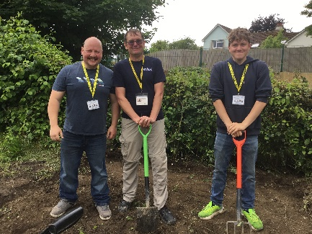
scheme
If you want to learn more about this school visit our
Facebook page.
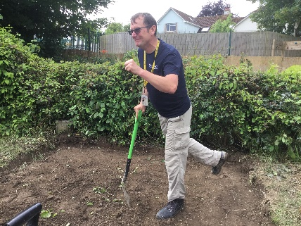

What do you think of the school?
Amazing! Nothing like our old school.
Why are you volunteering?
Community volunteering scheme. We volunteer at different places and help with what they need helping with.
Any good or bad thoughts?
Nothing bad, I love the pigs and the amount of space there is.
Would you do it again?
Absolutely!
What aspects do you admire of this school?
Quiet and calm.
When you were a child did you have a better school?
No, not as much equipment.

