Mrs J Harvey
Head Teacher
Lampard Community School
St John’s Lane
Barnstaple
Devon, EX32 9DD
Telephone: 01271 345416 e-mail: admin@lampard.devon.sch.uk www.lampard.devon.sch.uk

23rd June 2025
Dear Parents and Guardians,
School plays a vital role in the lives of our young people and this letter aims to provide essential information and guidance so that we can all best support them during this challenging time.
A child in our school has been diagnosed with a form of cancer that will require ongoing treatment over the next few years. This treatment will significantly weaken their immune system, making them highly susceptible to infections.
To help protect this child, we ask that you notify your child’s class teacher immediately if your child becomes ill. It is especially important to report cases of chickenpox, measles, mumps, shingles, hand-foot-and-mouth disease, whooping cough, and any other contagious or flu-like illnesses. This information is vital for the hospital to provide the necessary medical care and precautions for the child undergoing treatment.
We also urge you to strictly adhere to the 48-hour rule following any episode of sickness or diarrhoea before allowing your child to return to school. This measure is essential to prevent the spread of infections.
If anyone in your household has symptoms of measles, chickenpox, or shingles, it is particularly important to inform the school as soon as possible.
Please be assured that your child is not at any risk from this situation. However, the health and well-being of our pupil who is at risk depends on the cooperation of all parents, and we hope we can count on your support.
If you have any questions or concerns, please do not hesitate to speak with a member of our staff.
Thank you for your understanding and cooperation in helping us protect the health and well-being of all our students.
Sincerely,
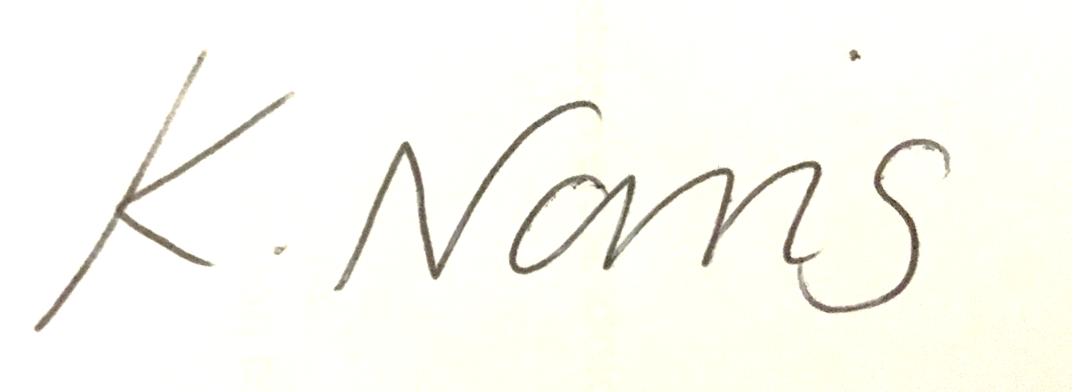
Kristel Norris
Assistant Head Teacher – Responsible for SEND

