WEEK ONE  Week Starting: 3.11.25, 24.11.25, 15.12.25, 19.1.26, 9.2.26, 9.3.26, 30.3.26  . |  |  |  |  |  |  |  |  | WEEK TWO  Week Starting: 10.11.25, 1.12.25, 5.1.26, 26.1.26, 23.2.26, 16.3.26
Choice | MONDAY (Meat Free) | TUESDAY | WEDNESDAY |  | THURSDAY |  | FRIDAY |  | Choice | MONDAY (Meat Free) | TUESDAY | WEDNESDAY | THURSDAY | FRIDAY
Option  One | Margherita Pizza  Potato Wedges, Sweetcorn & Salad Bar | Beef Bolognese  White & Wholemeal Pasta, Homemade Tomato and Herb Bread & Peas | Roast Gammon & Gravy  Roast Potatoes, Sliced Carrot & Green Beans |  | Spanish Chicken  White & Wholegrain Rice, Tortilla Chips &  Sweetcorn |  | Fish Cake  Chips, Peas & Baked Beans |  | Option  One | Tomato & Mozzarella Pasta Bake  Homemade Focaccia Bread, Sweetcorn & Fine Green Beans | Beef Burger with Ketchup  Potato Wedges, Coleslaw & Peas | Roast Chicken & Gravy  Roast Potatoes, Stuffing, Sliced Carrots & Broccoli | Pepperoni Pizza  Hash Brown Bites, Sweetcorn & Salad  Bar | Fish Fingers or Salmon Fingers  Chips, Salad Sticks & Baked Beans
Option  Two | Sweet & Sour Vegetables  White & Wholegrain Rice, Sweetcorn & Salad Bar | Mac ‘N’ Cheese  Homemade Tomato and Herb Bread & Peas | Vegetarian Sausage Toad in the Hole  Roast Potatoes, Sliced Carrot & Fine Green Beans |  | Spanish Vegetable & Butterbean Casserole  White & Wholegrain Rice, Tortilla Chips & Sweetcorn |  | Vegetable & Mixed Bean Lasagne  White & Wholegrain Rice, Tortilla Chips & Sweetcorn |  | Option  Two | Spinach & Potato Spanish Omelette  Home made Focaccia Bread, Sweetcorn & Fine Green Beans | Cajun Butternut Squash & Bean Burger  Potato Wedges, Coleslaw & Peas | Lentil & Vegetable Wellington  Roast Potatoes, Stuffing, Sliced Carrots & Broccoli | Vegetable Fajita  White & Wholegrain Rice Sweetcorn & Salad  Bar | BBQ Vegetarian Sausage  Chips, Peas & Beans
Dessert | Jam Sponge with Custard | Flapjack | Fresh Fruit Platter |  | Pear Cake |  | Chocolate Mousse |  | Dessert | Iced Sponge | Strawberry Jelly | Fresh Fruit Platter | Apple Cake | Chocolate Shortbread
Jacket Potato | Beans, Cheese, or Tuna mayo | Beans, Cheese, or Tuna mayo | Beans, Cheese, or Tuna mayo |  | Beans, Cheese, or Tuna mayo |  | Beans, Cheese, or Tuna mayo |  | Jacket Potato | Beans, Cheese, or Tuna mayo | Beans, Cheese, or Tuna mayo | Beans, Cheese, or Tuna mayo | Beans, Cheese, or Tuna mayo | Beans, Cheese, or Tuna mayo
Wrap | Ham, Cheese or  Tuna mayo | Ham, Cheese or Tuna mayo | Ham, Cheese or Tuna mayo |  | Ham, Cheese or Tuna mayo |  | Ham, Cheese or Tuna mayo |  | Wrap | Ham, Cheese or Tuna mayo | Ham, Cheese or Tuna mayo | Ham, Cheese or Tuna mayo | Ham, Cheese or Tuna mayo | Ham, Cheese or Tuna mayo
Students in Year 1 and Year 2 are entitled to a free school meal through the Universal Infant Free School Meals Scheme. Eligible students in Key Stage 2 (Years 3 to 6) are also entitled to Free School Meals. To find out if your child is eligible for Free School Meals apply through Devon County Council’s Citizens Portal. If your application is successful, please send proof of eligibility to the school office (admin@lampard.devon.sch.uk)  School Meals cost £2.50 for Years 3-6 & £2.80 for Years 7-11.  Our preferred method of payment is via ParentPay. Meals must be paid for in advance or on the day the meal is taken. Please do not allow your child’s dinner account to become overdrawn. We may ask you to provide packed lunch for your child whilst overdrawn accounts are cleared. |  |  | WEEK THREE  Week Starting: 17.11.25, 8.12.25, 12.1.26, 2.2.26, 2.3.26, 23.3.26 |  |  |  |  |  |  |  |  | 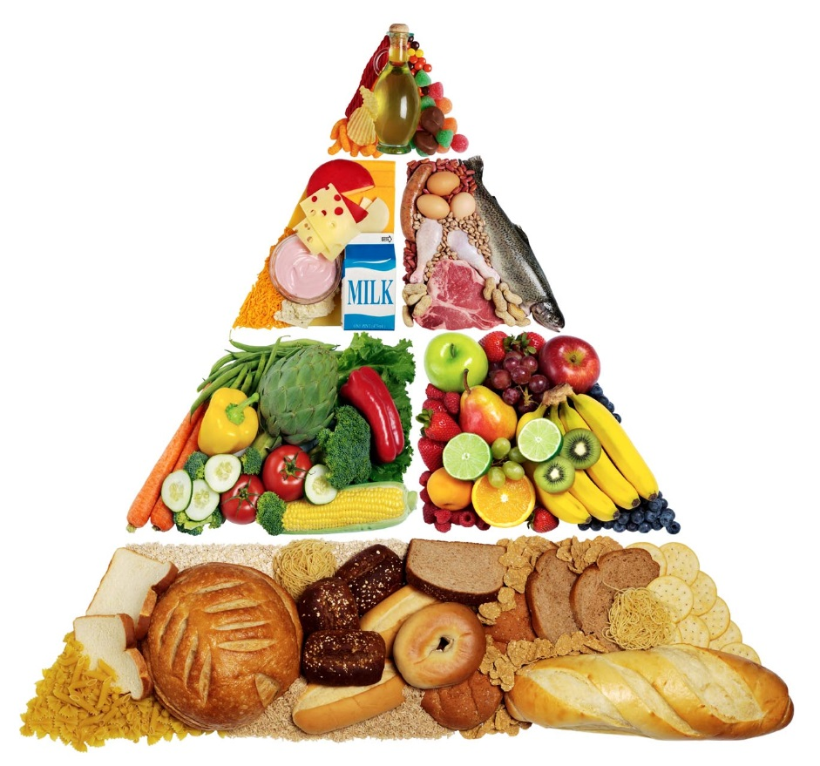
 |  |  | Choice | MONDAY (Meat Free) |  | TUESDAY |  | WEDNESDAY |  | THURSDAY | FRIDAY
 |  |  | Option  One | Butternut Squash & Chickpea Curry  White & Wholegrain Rice, Nann & Fresh Chopped Salad |  | Creamy Chicken & Tomato Pasta Bake with Garlic Focaccia, Peas |  | Roast Pork & Gravy  Roast Potatoes, Sliced Carrots & Cabbage |  | Pork Sausage & Mash  Broccoli, Green Beans & Gravy | Breaded Fish  Chips Peas & Beans
 |  |  | Option  Two | Vegetarian Hotdog  Roasted New Potatoes, Rainbow Slaw & Sweetcorn |  | Roasted Vegetable Quiche  Half a Jacket Potato, Peas & Salad Sticks |  | Broccoli & Cauliflower Cheese Bake  Roast Potatoes, Sliced Carrots & Cabbage |  | Cheesy Potato Wheels  Broccoli & Green Beans | Cheese & Bean Pasty  Chips, Peas & Beans
 |  |  | Dessert | Oaty Cookie |  | Orange Sticky Toffee Cake |  | Fresh Fruit Platter |  | Carrot Cake | Bananas & Custard
 |  |  | Jacket Potato | Beans, Cheese, or Tuna mayo |  | Beans, Cheese, or Tuna mayo |  | Beans, Cheese, or Tuna mayo |  | Beans, Cheese, or Tuna mayo | Beans, Cheese, or Tuna mayo
 |  |  | Wrap | Ham, Cheese or Tuna mayo |  | Ham, Cheese or Tuna mayo |  | Ham, Cheese or Tuna mayo |  | Ham, Cheese or Tuna mayo | Ham, Cheese or Tuna mayo

